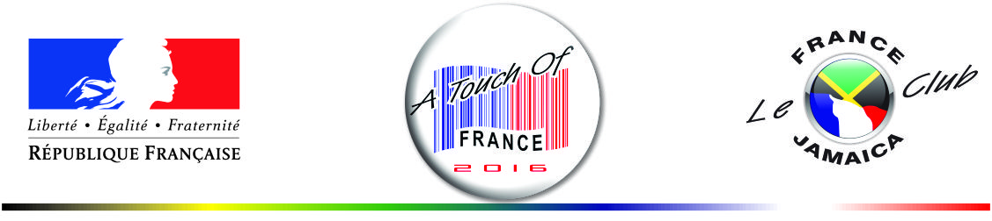

CONTRACT OF PARTICIPATION TO

“A TOUCH OF FRANCE 2016”

Novembre 23 - 25 2016, Spanish Court Hotel (Kingston)

We __________________________________________________ accept to participate to « A TOUCH OF FRANCE
^{(company name)}
2016 » as follow:

PARTENAIRES SPONSOR JUNIOR SPONSOR
- - JA$ 250,000 - JA$ 150,000

EXHIBITORS (Please tick selected option)
OPTION I | - JA$60,000 Single BoothSpace  - 8’X8’ Booth space, including one table with skirting, 2 chairs and electrical outlet
OPTION II | - JA $120,000 Double Booth Space  - 16’X 8’ Booth space, including 2 tables with skirting, 4 chairs and electrical outlet
ON THE BOOTH SELLING OPTION | An additional JA$60,000 is requested from exhibitors selling products on their booth.

Name of company: ______________________________________________  Address: _____________________________________________________  _____________________________________________________  Phone : __________________ Fax : ____________________  email : _______________________________________________________  contact name: _________________________________________________  Position: _____________________________________________________ | Company stamp

Date : _____________________ Signature : ______________________________

Please make cheque payable to «Le Club France Jamaica ltd»

